** MINISTRY OF EDUCATION AND TRAINING**

**FPT UNIVERSITY**

Capstone Project Document

Find Fit Shoes

|  |  |
| --- | --- |
| **Group 12** | |
| **Group members** | Hoàng Trung Hiếu – Team Leader – SE60766  Nguyễn Mạnh Khương – Team Member - 60455  Nguyễn Thị Hồng – Team Member – SE60592 |
| **Supervisor** | Mr. Kiều Trọng Khánh |
| **Ext. Supervisor** | N/A |
| **Capstone Project code** | FFS |

-Ho Chi Minh City, 09/2014-

*This page is intentionally left blank*

***ACKNOWLEDGEMENTS***

We wish to thank various people for their contribution to this project: Our teachers for their advice and participation in the final review, our friends for their valuable technical support.

Special thanks should be given to Mr. Kiều Trọng Khánh, our research supervisor for his professional guidance and the useful, constructive recommendations throughout the course of this project.

# Contents

1 Contents 4

List of Tables 4

2 Problem Definition 5

2.1 Name of this CapStone Project 5

2.2 Problem Abstract 5

2.3 Project Overview 5

2.3.1 The Current System 5

2.3.2 The Proposed System 5

2.3.3 Boundaries of the System 6

2.3.4 Development Environment 6

3 Project organization 6

3.1 System Process Model 6

3.2 Roles and Responsibilities 7

3.3 Tools and Techniques 8

4 Project management plan 8

4.1 Iteration 8

4.2 Iteration Detail 9

4.2.1 Phase 1: Preliminary Investigation or Analysis 9

4.2.2 Phase 2: Data Management 9

4.2.3 Phase 3: Support Order function 10

4.2.4 Phase 4: Main User’s Functions 10

4.2.5 Phase 5: Account Management 11

4.3 All Meeting Minutes 11

**Refer to Meeting Minutes folder.** 11

# List of Tables

Table 1: Roles and Responsibilities 7

Report No.2: Project Management Plan (PMP)

# Problem Definition

## Name of this CapStone Project

Find Fit Shoes(FFS)

## Problem Abstract

In recent years, the development of e-commerce in Vietnam brings significant changes and conveniences in our life. Instead of going to the conventional retail stores to choose the things to buy in tradition way, we can order many kinds of product by online shopping. There is a number of e-commerce websites allow us to buy a wide range of items, and delivery to your home that can be time saving and lower cost, but they also have some disadvantages. We usually see product through some pictures and details, and if we want to experience the product before purchase, they do not allow that. When we want to buy a shoe, which is really a big problem. We cannot check how the shoe feels on our feet. And we do not know exactly our feet size fit which size in several different shoe-size systems.

That’s why users have had the frustrating experience of ordering shoe online, only to find that the shoes do not fit their feet correctly. And when they have to return back, it’s really time-consuming and cost-ineffective for both buyer and seller. Our system will, therefore, help users to deal with this problem, find the shoes which fit to their true size on the current selling shoe websites in Vietnam and support users order them.

## Project Overview

### The Current System

Most of current e-commerce website, particularly in Vietnam, just sell shoe like other items. They have search and filter functions depend on some criteria like brand, style, price, color, origin and so on. Users usually decide to order a product rely on some descriptions and images that provided from these websites such as zalora.vn, lazada.vn, giaytot.com, giayworld.com, etc. Some websites have the articles or tips that guide user how to choose the shoes fit to their size. However, no website, currently, has any functions that allow user to input their feet size in order to calculate their true shoe size in different shoe-size system and suggest the shoes fit to them.

### The Proposed System

The system will support users to input their feet size to calculate shoe size in the different system and suggest the shoes that are sold at the parsed websites in Vietnam then support to order them. The system will have the following functions:

* Administrators can manage the system, manage accounts, and configure system.
* System can parse the current selling shoe website to get the useful information, recommend or suggest shoes fit user’s size, support order product online.
* Staff will define or configure and train the parser that collects data from other webs to mine.
* Users can calculate their shoe size based on inputted feet size, search the available products in the parsed website.
* Trainings module will help system recognize products are already existed in database.

### Boundaries of the System

The system can be used by every people with a laptop/computer with

Internet connection.

- The system is not intended for managing these aspects:

+ Managing product quality.

+ Managing your expense.

- The language of the system is English.

- The complete product includes:

+ The website, for staff and user.

+ All the process document involved.

### Development Environment

#### Hardware requirements

|  |  |  |
| --- | --- | --- |
| Windows Minimum | Requirements | Recommended |
| Internet Connection | Wifi (4 Mbps) Cable | Wifi (8 Mbps) |
| Operating System XP | XP, Vista, 7, 8 | XP, Vista, 7, 8 |
| Computer Processor | Intel® Core 2 Duo Intel® | Core(TM) i5 CPU , M  460 @ 2.53GHz |
| Computer Memory | 1GB RAM | 3GB or more |

#### Software requirements

Microsoft Windows 7 Ultimate: operating system and platform for

development.

- SQL Server 2008 Enterprise R2: used to create and manage the

database for system.

- Star UML: used to create models and diagrams.

- Skype: used for communication and meeting.

- Visual Studio 2012: used to implement website.

- Google Code & Tortoise SVN: used for source control.

# Project organization

## System Process Model

Project is developed under Agile Unified Process (AUP).

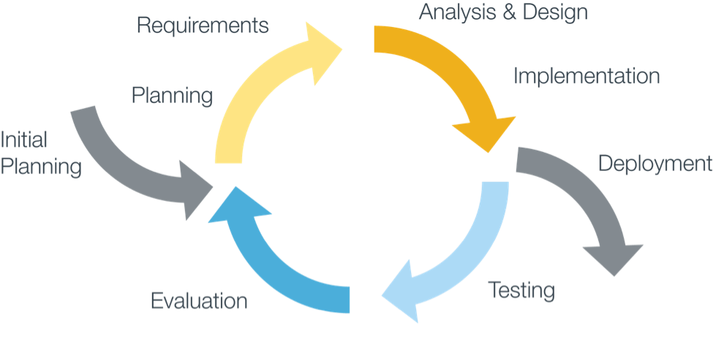

Figure 1: Agile Unidied Development Model

For more information: http://www.ambysoft.com/unifiedprocess/agileUP.html

http://en.wikipedia.org/wiki/Agile_Unified_Process

## Roles and Responsibilities

|  |  |  |  |  |  |
| --- | --- | --- | --- | --- | --- |
| No | Full name | Role in Group | | Responsibilities | |
| 1 | Kieu Trong Khanh | | Project manager | | * Specify user requirement * Control the development process * Give out technique and business analysis support | |
| 2 | Hoàng Trung Hiếu | Team Leader,  BA, DEV, Tester | | * Managing process * Designing database * Clarifying requirements * Prepare documents * GUI Design * Create test plan * Coding * Testing | |
| 3 | Nguyễn Mạnh Khương | Team Member,  BA, DEV, Tester | | * Designing database * Clarifying requirements * Prepare documents * GUI Design * Create test plan * Coding * Testing | |
| 4 | Nguyễn Thị Hồng | Team Member,  BA, DEV, Tester | | * Designing database * Clarifying requirements * Prepare documents * GUI Design * Create test plan * Coding * Testing | |

Table 3: Roles and Responsibility Details

## Tools and Techniques

- Front-end technologies: HTML5, CSS3, JavaScript, jQuery, AJAX.

- Back-end:

+ Website: ASP.NET MVC4 + Entity Framework 5.

+ Scheduler: Quartz.

+ Parse data from Excel file: Linq to excel.

- Web Server: Microsoft IIS.

- Database Management System: MS SQL Server 2008 Enterprise R2.

# Project management plan

## Iteration

|  |  |  |  |  |  |
| --- | --- | --- | --- | --- | --- |
| **Phase**  **/Iteration** | **Description** | **Deliverables** | **Resource needed** | **Dependencies and Constrains** | **Risks** |
| **Preliminary Investigation or Analysis** | - Study similar existing systems.  - Identify and clarify requirements for the system in general. | - Introduction of proposed system.  - Main functions.  - Project Iteration Plan. | 30 man-days | N/A | Project may  not be feasible  for developing  because lack of technologies  And/or data. |
| **Data management** | - Build parser to crawl selling shoe website.  - Manage data in database. | - Parser system.  - Data management system. | 20 man-days | N/A | Lack of experience.  The implemented parsers are not the best.  Lack of test data. |
| **Support Order function** | - Support user order product via the parsed websites. | - Order service. | 20 man-days | Depends on “Data management”. | Other website have different way to order. Technical obstacle. |
| **Main user’s functions** | - User can search a product.  - Input their feet size to calculate the shoe size.  - Let user see details of each product.  - Suggest shoe meet user criteria. | - Main user’s functions on web. | 20 man-days | Depend on “Data management”. | Lack of experience.  Not have a clear understanding about business process. |
| **User Account**  **management** | - Manage user accounts in the system | - User management system. | 10 man-days | N/A | Lack of experience.  Not have a clear understanding about business process. |

Table 3: Iteration

## Iteration Detail

### Phase 1: Preliminary Investigation or Analysis

|  |  |  |
| --- | --- | --- |
| **Task** | **Description** | **Author** |
| **1. Identifying and studying existing systems** | Find which systems currently provide similar service, their strengths and weakness. | HieuHT, HongNT, KhuongNM |
| **2. Identifying and clarifying main functions.** | Define which main functions system should provide. | HieuHT |
| **3. Introduction.** | Complete Introduction Report. | HieuHT |
| **4. Project Management**  **Plan.** | Prepare Project  Management Plan. | HieuHT |
| **5. Website Prototype.** | Build a prototype of proposed system. | HieuHT, HongNT, KhuongNM |
| **6. Design ER diagram.** | Design ER diagram. | HieuHT, HongNT, KhuongNM |

### Phase 2: Data Management

|  |  |  |
| --- | --- | --- |
| **Task** | **Description** | **Author** |
| **1. Identifying Requirement and Planning** | Which feature this function should have and how to implement. | HieuHT, KhuongNM |
| **2. Create parsers** | Create appropriate parsers to parse data from many websites. | KhuongNM |
| **4. Implement GUI** | Create the interface for user. | KhuongNM, HongNT |
| **5. Testing** | Test system behavior and  performance  Test user behavior and  performance | HieuHT, HongNT, KhuongNM |
| **6. Document** | Adding SRS, SDD,  Installation Guide, Manual  Guide | HieuHT, HongNT, KhuongNM |

Table 5: Phase 2: Data Management

### Phase 3: Support Order function

|  |  |  |
| --- | --- | --- |
| **Task** | **Description** | **Author** |
| **1. Identifying Requirement and Planning** | Which feature this function should have and how to implement. | HieuHT |
| **2. Place order using iframe or via the parsed website** | Allow user order product in our website using iframe or via the parsed website. | HieuHT |
| **3. Add a new order website function by load dynamic lib.** | Implement each website have different order way by load dynamic lib. | HieuHT |
| **4. Testing** | Test system behavior and  performance  Test user behavior and  performance | HieuHT, HongNT, KhuongNM |
| **4. Document** | Adding SRS, SDD,  Installation Guide, Manual  Guide | HieuHT, HongNT, KhuongNM |

Table 6: Phase 3: Support Order function

### Phase 4: Main User’s Functions

|  |  |  |
| --- | --- | --- |
| **Task** | **Description** | **Author** |
| **1. Identifying Requirement and Planning** | Which feature this function should have and how to implement. | HieuHT, HongNT |
| **2. Search Product** | Allow user to search product | HongNT |
| **3. Shoe size calculation** | Input their feet size to calculate the shoe size. | HongNT |
| **4. View Product ‘s Details** | Allow user view details of the product. | HongNT |
| **5. Shoe suggestion** | Suggest shoe meet user criteria. | HongNT |
| **6. Manage User** | Allow staff to manage user accounts. | HongNT |
| **7. Testing** | Test system behavior and  performance  Test user behavior and  performance | HieuHT, HongNT, KhuongNM |
| **8. Document** | Adding SRS, SDD,  Installation Guide, Manual  Guide | HieuHT, HongNT, KhuongNM |

Table 6: Phase 4: User Related Functions

### Phase 5: Account Management

|  |  |  |
| --- | --- | --- |
| **Task** | **Description** | **Author** |
| **1. Identifying Requirement and Planning** | Which feature this function should have and how to implement. | HieuHT, HongNT, KhuongNM |
| **2. Manage account** | Staff can manage accounts in the system. | KhuongNM |
| **3. Testing** | Test system behavior and  performance  Test user behavior and  performance | HieuHT, HongNT, KhuongNM |
| **4. Document** | Adding SRS, SDD,  Installation Guide, Manual  Guide | HieuHT, HongNT, KhuongNM |

Table 8: Phase 5: Account Management

## All Meeting Minutes

**Refer to Meeting Minutes folder.**